**Data Structures and Algorithms:**

**Data Structures**-Structures used to store the data like array,linked list,trees,graphs,queues,stacks,hashmaps etc.

**Algorithms-**processes/operations performed on the data stored in data structures like searching,sorting,finding the shortest path from source to destination.

**Importance of DSA:**To crack technical Interviews(give examples where you were asked or you asked DSA in Interviews or mocks etc.)

**Uses of DSA:**

Tries-search engines  
(google search)

Graphs-Google maps

Linked List -Music player

Trees-files and folders

**Time Complexity**:No. of Iterations or how many elements are touched or disturbed and how many times.

**Time Complexity!=Time taken** to excecute the code as time taken is machine dependent.

example-Old windows and new Macbook might excecute the same code in different times.

**Different Time Complexities:**

**Constant TC:**fixed no. of iterations or no iteration

Example if-else code snippet

Print statement

Etc.

**Linear TC:**

**Single loop**

let n = 10; // You can set n to any positive integer

for (let i = 1; i <= n; i++) {

console.log(i);

}

For i=1,1 time till now it has run

i=2,till now 2 times it has run

.

.

.

i=n,n times till now it has run

TC:O(n) where is n is the input given and total n iterations happened means n elements are disturbed one time each.

or,

**multiple loops independent of each other**

let n = 10; // Set n to any positive integer

let m = 5; // Set m to any positive integer

// Loop from 1 to n

console.log('Loop from 1 to n:');

for (let i = 1; i <= n; i++) {

console.log(i);

}

For i=1,1 time till now it has run

i=2,till now 2 times it has run

.

.

.

i=n,n times till now it has run

// Loop from 1 to m

console.log('Loop from 1 to m:');

for (let j = 1; j <= m; j++) {

console.log(j);

}

For i=1,1 time till now it has run

i=2,till now 2 times it has run

.

.

.

i=m,m times till now it has run

TC:O(n+m) where in n,m is the input given and total n iterations happened means n,m elements are disturbed one time each.

**Squared TC:**

let n = 5; // You can set n to any positive integer

let m = 3; // You can set m to any positive integer

for (let i = 1; i <= n; i++) {

for (let j = 1; j <= m; j++) {

console.log(`i: ${i}, j: ${j}`);

}

}

TC:O(n*m)

n elements are iterated or disturbed m times each.

For i=1,m iterations are done

i=2,m iterations are done

.

.

i=n,m iterations are done

**Logarithmic TC:**

let n = 64; // You can set n to any positive integer

while (n > 1) {

n = Math.floor(n / 2); // Divide n by 2 and round down to the nearest integer

}

N=1,0 iterations

N=2,1 iteration(2/2=1 then no further iteration)

N=3,1 iteration(3/2=1 then no further iteration)

N=4(2 iterations(4/2,2/2, then no further iteration)

.

.

.

N=8(3 iterations,8/2,4/2,2/2, then no further iteration)

Each time we are reducing i to its half that is n/2->n/4->n/8 —------n/n until it becomes 1.

So the time is O(log base2 of n) as in log base2 n steps we can reduce n to 1.

**Underroot Time Complexity:**

let n = 100; // You can set n to any positive integer

for (let i = 1; i * i <= n; i++) {

console.log(i);

}

TC:O(root n)

**Graphical representation of Different Time Complexitites:**

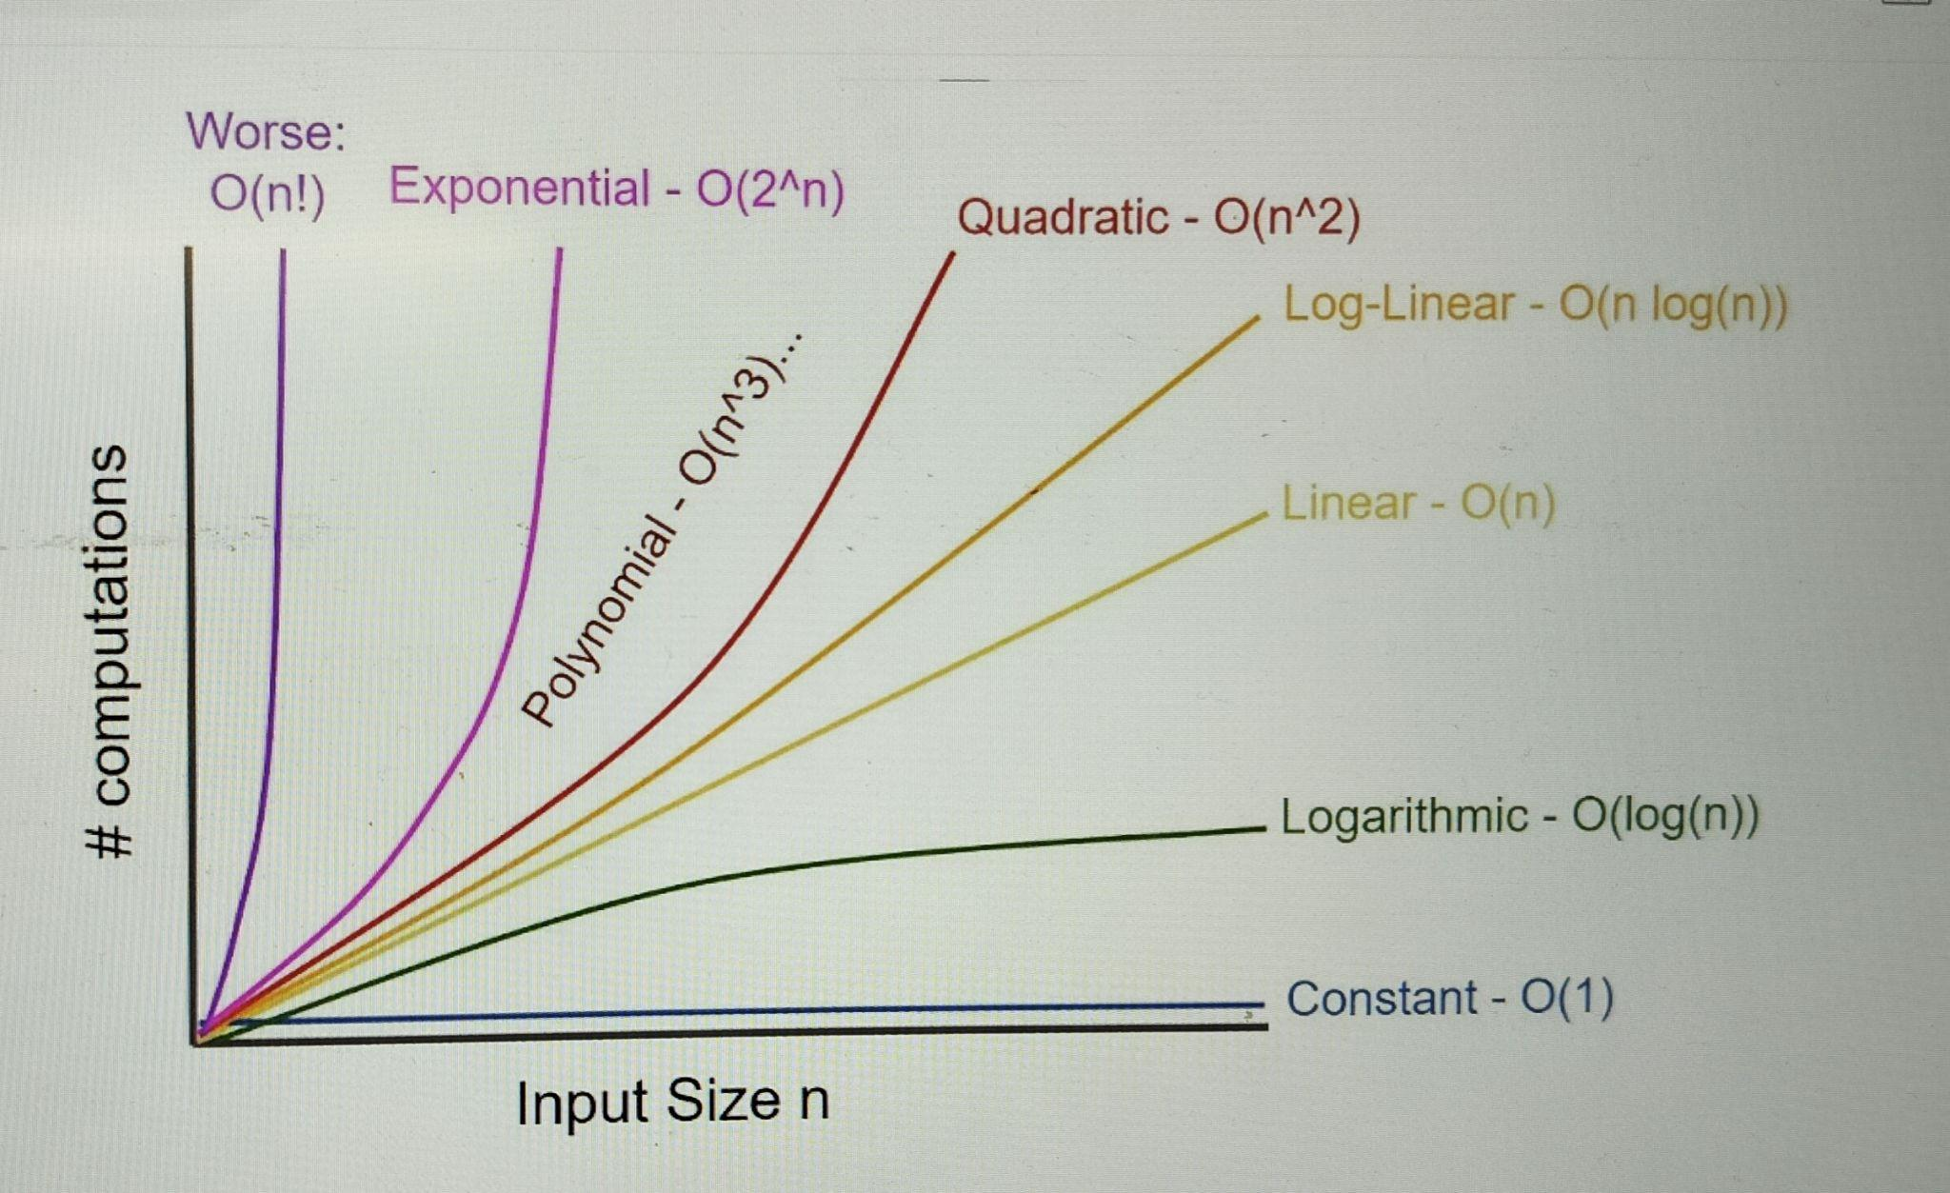

O(1) TC:When it’s the good case and one iteration is performed.

O(logn):Example binary search

O(n):When n elements are traversed.

O(n^2,n^3,-----,n^k):Polynomial in cse of multi-dimensional array.

O(2^n):Exponentail:in recursive functions mostly.

O(n!):in case of permutations and combinations

**Rules to write time complexity:**

1.write the overall complexity of code

2.Erase all lower complexities leaving the higher TC only

3.Ignore constants

**Why Erase all lower complexities leaving the higher TC only?**

Example: N^2+10N

Input size Iterations % of lower complexity in total overall complexity

N=10 10^2+10(10) 100/200*100=50%

100+100

N=100 100^2+10(100) 1000/11000*100=9% something

10000+1000

N=1000 1000^2+10(1000) 10000/1001000*100=0.something

1000000+10000

Each time the input increases the affect of lower TC’s is decreasing

**Why Ignore constants?**

2n and 3n is both linear no matter n is getting multiplied by 2 or 3.

Also,

for (let i = 1; i <= n; i++) {

console.log(i);

}

In this for every i,three operations are fixed i.e. checking the condition,excecuting statements inside curly brackets and incementing i.

So n*3 is the complexity if n changes from 10 to 50 stills these 3 operations are fixed.

So,constant never changes with increase in input.

**Space Complexity:**

Given Space:Given to you in problems itself.

Auxiliary Space:That you use on your own to solve a problem.

Examples etc.

**Graphical representation of Different Time Complexitites:**

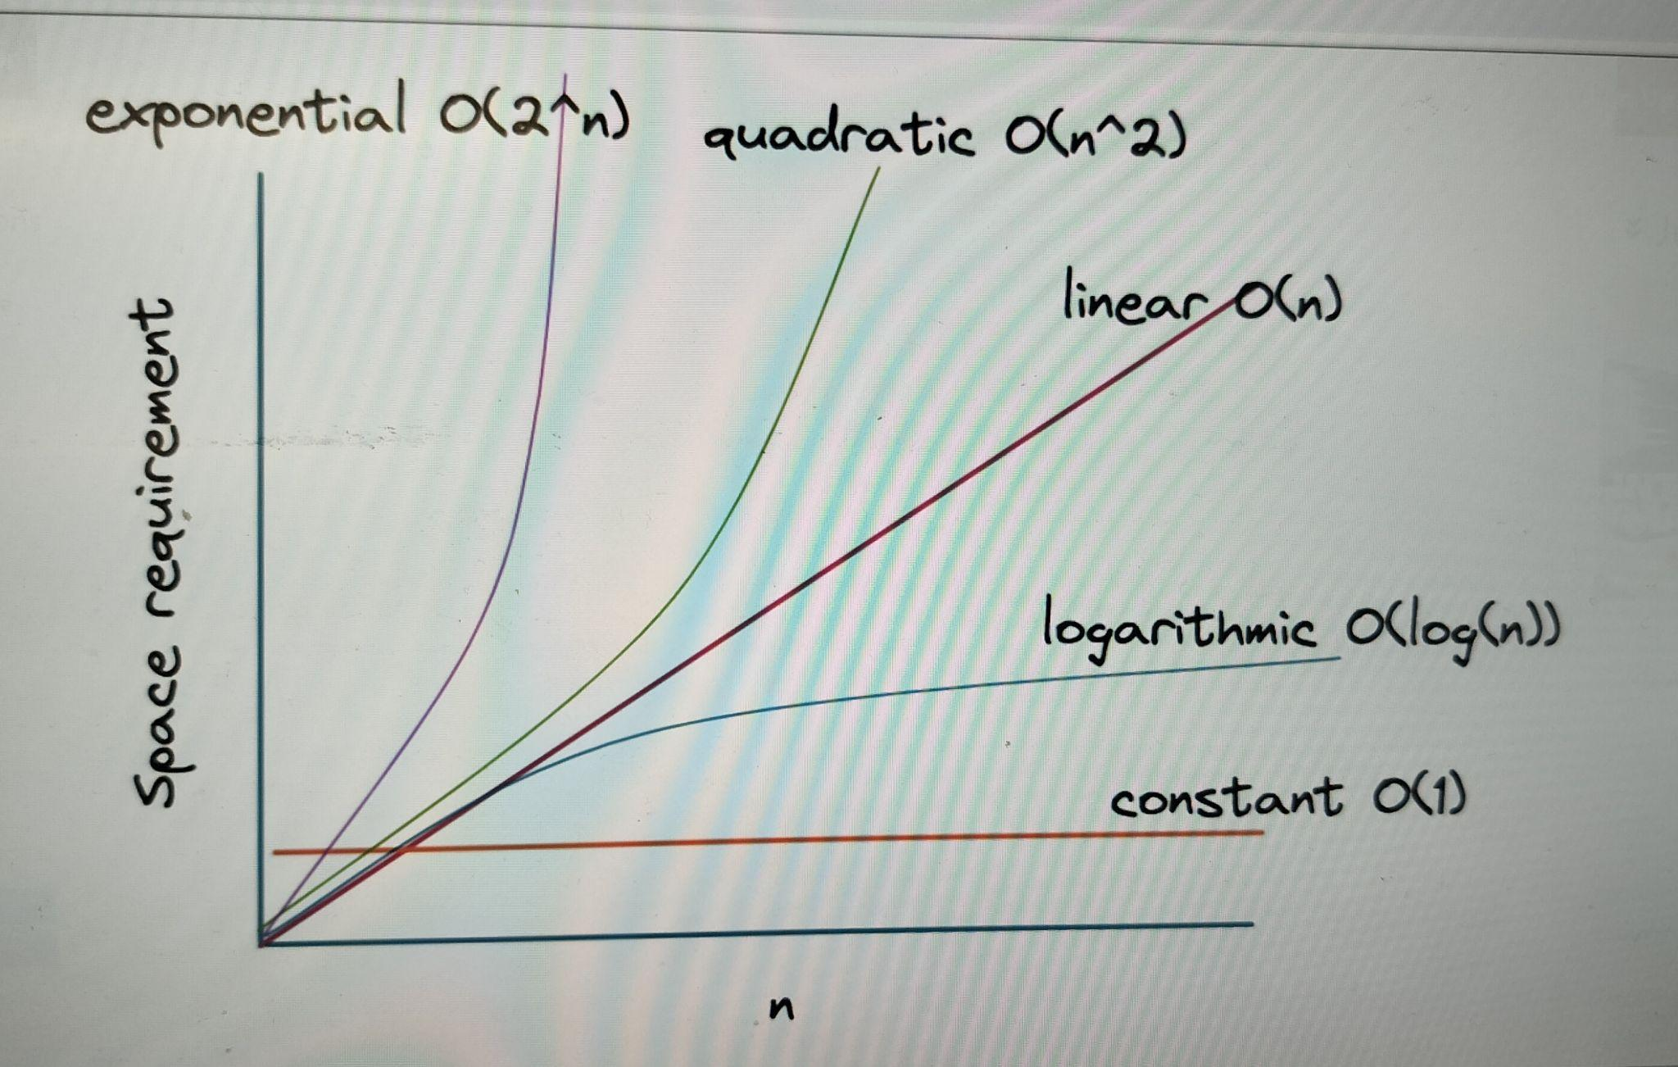

* An algorithm that uses a single variable has a constant space complexity of O(1).
* Recursive Functions calls for Binary Search takes logn space to get stored inside stack space.
* A method that requires an array of n elements has a linear space complexity of O(n).
* Computations using [a matrix](https://algodaily.com/lessons/implementing-graphs-edge-list-adjacency-list-adjacency-matrix) of size m*n have a space complexity of O(m*n).
* An algorithm uses exponential space-complexity as 2^n when after each level recursive calls gets doubled.Example-Fibonacci